Day – 4
BIOS and POST Troubleshoot theory
1.List 5 common BIOS or POST error messages you might see when starting a PC and write what hardware or configuration issue each one usually points to.
5 Common BIOS or POST Error Messages and What They Mean
When you turn on a computer, the BIOS (Basic Input/Output System) performs a POST (Power-On Self-Test). POST checks important hardware components such as the RAM, keyboard, storage drive, processor, and graphics hardware before the operating system starts.
If the BIOS detects a problem, it may display an error message on the screen or produce beep codes.
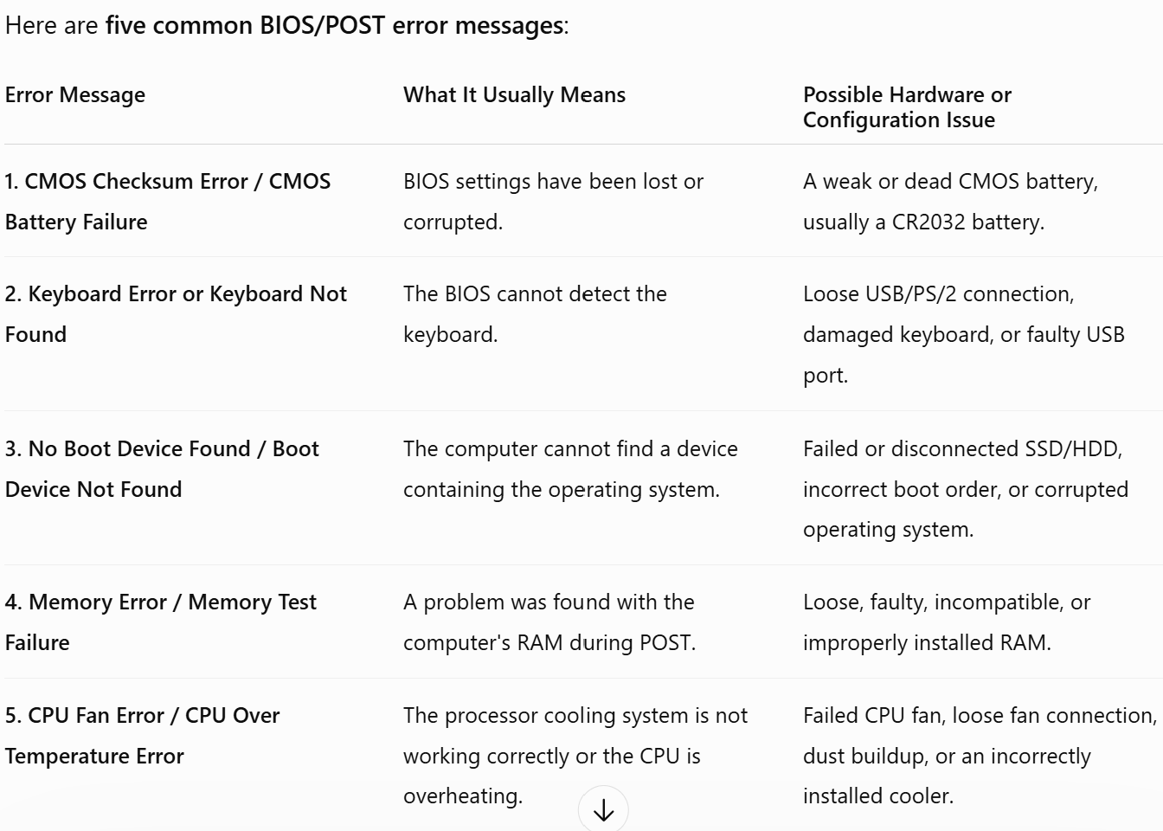

1. CMOS Checksum Error
Example message:
CMOS Checksum Error – Defaults Loaded
This error means that the BIOS has detected that its stored configuration settings are incorrect or have been lost.
Common cause:
The small CMOS battery on the motherboard may be weak or dead.
Real example:
If the computer repeatedly forgets the correct date and time every time it is switched off, the CMOS battery may need to be replaced.
Solution:
Replace the CMOS battery and reconfigure the BIOS settings if necessary.
2. Keyboard Error or Keyboard Not Found
Example message:
Keyboard Not Found
This means the BIOS cannot communicate with the keyboard during startup.
Possible causes:
- Keyboard cable is loose.
- USB port is faulty.
- Keyboard is damaged.
- Wireless keyboard battery or connection has failed.
Solution:
Check the connection, try another USB port, or test the computer with another keyboard.

3. No Boot Device Found
Example message:
No Boot Device Found
Boot Device Not Found
This means the BIOS cannot find a storage device containing the operating system, such as Windows.
Possible causes:
- SSD or HDD is disconnected or has failed.
- The boot order in the BIOS is incorrect.
- The operating system or boot files are corrupted.
Real example:
If a computer has Windows installed on its SSD but the SSD is not detected because its cable is loose, the computer may display this error instead of starting Windows.
Solution:
Check whether the SSD/HDD is detected in the BIOS, verify its connections, and check the boot order.
4. Memory Error or Memory Test Failure
Example message:
Memory Test Failed
Memory Error
During POST, the BIOS checks the RAM (Random Access Memory). This error indicates that the RAM may not be functioning correctly.
Possible causes:
- RAM module is loose.
- RAM is faulty.
- RAM modules are incompatible.
- A motherboard RAM slot is damaged.
Solution:
Turn off the computer, remove and carefully reinstall the RAM. If the problem continues, test one RAM module at a time.

5. CPU Fan Error or CPU Over Temperature Error
Example message:
CPU Fan Error
CPU Over Temperature Error
This warning indicates a problem with the processor's cooling system.
Possible causes:
- CPU fan is not spinning.
- Fan cable is disconnected from the motherboard.
- Excessive dust is blocking airflow.
- The CPU cooler is not installed properly.
Why is this important?
The CPU produces heat while working. Without proper cooling, it can overheat, causing the computer to slow down, shut down unexpectedly, or potentially suffer hardware damage.
Solution:
Check that the CPU fan is connected and spinning properly, clean dust from the cooling system, and ensure the CPU cooler is correctly installed.

2.Given this scenario: On boot, a PC beeps 3 times in a repeating pattern and does not display anything on the screen. Research and write what this POST beep code typically means for an AMI BIOS, and suggest two troubleshooting steps.
POST Beep Code Scenario: 3 Beeps on an AMI BIOS
Scenario
When the PC is turned on, it produces 3 beeps in a repeating pattern and nothing appears on the screen.
What does 3 beeps typically mean?
For a traditional AMI (American Megatrends) BIOS, three short beeps typically indicate a memory (RAM) problem. More specifically, it can point to a failure during the RAM initialization or memory test performed during the POST process.
POST (Power-On Self-Test) is the process in which the computer checks essential hardware components before starting the operating system. Since RAM is required for the computer to operate properly, a RAM problem can prevent the PC from completing POST and displaying anything on the monitor.
Important: Beep codes can vary depending on the motherboard manufacturer and BIOS/UEFI version. Therefore, the motherboard manual should be checked to confirm the exact meaning.
Two Troubleshooting Steps
1. Reseat the RAM
Turn off the PC and disconnect it from the power supply. Open the computer and carefully remove the RAM modules. Then reinstall them firmly in their slots.
Why?
Sometimes a RAM module may become loose or have poor contact with the motherboard, causing the BIOS to detect a memory error.
2. Test the RAM Modules Individually
If the PC has more than one RAM module, remove all but one and try starting the computer. Repeat this process with each RAM module and, if possible, try different RAM slots.
Why?
This helps identify whether the problem is caused by a faulty RAM module or a damaged motherboard RAM slot.
Conclusion
A 3-beep code on a traditional AMI BIOS generally indicates a RAM or memory-related problem. The first steps should be to reseat the RAM and then test each RAM module individually. If the problem continues, the faulty RAM module or motherboard slot may need to be replaced.
3.Access the BIOS setup utility on any available PC or virtual machine, take a screenshot of the main BIOS screen, and identify the motherboard manufacturer and BIOS version.
Accessing the BIOS Setup Utility and Identifying BIOS Information
Objective
The purpose of this task is to access the BIOS Setup Utility, view the main BIOS screen, and identify the motherboard manufacturer and BIOS version.
What is BIOS?
BIOS (Basic Input/Output System) is firmware stored on the motherboard. When a computer is turned on, the BIOS performs the POST (Power-On Self-Test) and checks important hardware components before the operating system starts.
The BIOS Setup Utility allows users to view and change basic system settings, such as:
- System date and time
- Boot order
- Installed hardware
- BIOS version
- Security settings

Steps to Access the BIOS Setup Utility
Step 1: Restart or turn on the PC
Start the computer and watch the screen carefully during the first few seconds of startup.
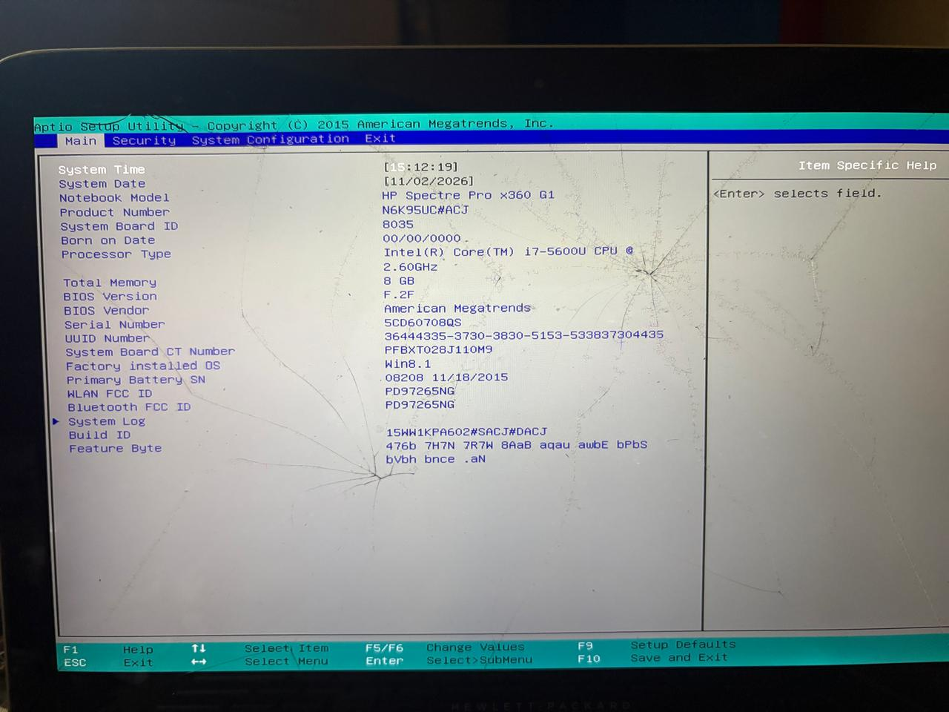
Explanation
The BIOS Setup Utility is used to view and configure important system settings before the operating system starts. In this system, the BIOS vendor is American Megatrends, Inc. (AMI), while the computer manufacturer is HP.
The BIOS version displayed on the screen is F.2F.
Final Answer
I accessed the BIOS Setup Utility and viewed the Main BIOS screen. The system is manufactured by HP, and the laptop model is HP Spectre Pro x360 G1. The BIOS vendor is American Megatrends, Inc., and the BIOS version is F.2F. The BIOS screen also shows that the system has an Intel Core i7-5600U processor and 8 GB of memory.
Screenshot evidence: You can use the photo you captured as the screenshot for your assignment because it clearly shows the BIOS version, BIOS vendor, laptop model, processor, and memory information.
Small clarification: Your screen does not explicitly show a separate motherboard manufacturer. Since this is a laptop, HP (the system manufacturer) is the appropriate information to report for this assignment.

4.You are given a screenshot of a POST error message that says 'CMOS checksum error – Defaults loaded.' Explain what this means and describe how you would resolve this issue in a real system.
CMOS Checksum Error – Defaults Loaded
What does this error mean?
The message “CMOS checksum error – Defaults loaded” means that the computer's BIOS has detected a problem with the settings stored in the CMOS memory.
The CMOS stores important BIOS configuration settings, such as:
- System date and time
- Boot order
- Hardware configuration settings
A checksum is a value used by the BIOS to check whether the stored data is correct. If the stored settings do not match the expected checksum, the BIOS assumes that the settings may be corrupted or lost. It then loads the default BIOS settings so that the computer can start safely.
Common Cause
The most common cause is a weak or dead CMOS battery. This small battery, usually a CR2032 battery in desktop computers, provides power to retain the BIOS settings when the computer is turned off.

How I Would Resolve the Issue
Step 1: Check the Date and Time
First, I would enter the BIOS Setup Utility and check whether the date and time are incorrect or resetting. This is a common sign of a weak CMOS battery.
Step 2: Replace the CMOS Battery
If the battery is weak or dead, I would:
- Shut down the computer and disconnect the power.
- Open the computer case.
- Locate and carefully replace the CMOS battery with the correct type.
- Reconnect the power and start the computer.
Step 3: Reset and Save BIOS Settings
After replacing the battery, I would enter the BIOS Setup Utility and:
- Set the correct date and time.
- Check important settings such as the boot order.
- Load or confirm the correct BIOS settings.
- Save the changes and restart the computer.
Conclusion
The “CMOS checksum error – Defaults loaded” message usually indicates that the BIOS settings have been lost or corrupted, often because of a weak CMOS battery. Replacing the battery and reconfiguring the BIOS settings usually resolves the issue

